**Linear Algebra**

**🔹 What is Linear Algebra?**

Linear Algebra is the **mathematics of vectors and matrices**. It helps in solving systems of equations, transforming data, and optimizing models.

**Simple Example:**  
Imagine you have a dataset of 1000 users, and each user has **3 features**:

* Age
* Salary
* Experience

This dataset can be represented as a **1000×3 matrix**, where each row is a user and each column is a feature.

**In Data Science, everything is stored in vectors and matrices!**

**🔹 Why is Linear Algebra Important for Data Science?**

✔️ **Data Representation:** Data is stored in matrix form.  
✔️ **Machine Learning:** Algorithms like Linear Regression use matrix multiplication.  
✔️ **Deep Learning:** Neural networks use matrix operations for fast computations.  
✔️ **Dimensionality Reduction:** PCA (Principal Component Analysis) uses **eigenvalues and eigenvectors** to reduce data size.

**Example:**  
When training a machine learning model, the equation used is:

Y=XW+ b

where:

* X = Matrix of input features
* W = Weight vector
* b = Bias term
* Y = Predicted output

**What is Scalar**

A **scalar** is just **one** number. It has **only magnitude**, no direction.  
Example: **5, -3.2, 100, π (3.14)**

📌 **Python Example:**

scalar = 5

print(scalar) # Output: 5

💡 **Where is Scalar Used?**

* **Temperature (°C, °F)** → "It's 30°C today."
* **Weight (kg)** → "The box weighs 10 kg."
* **Speed (m/s)** → "Car is moving at 60 km/h."

**What is Vector?**

A **vector** is a **list of numbers** representing **magnitude + direction**.  
Example: **[3, 4]** represents movement in **x and y directions**.

A **vector** is a one-dimensional array of numbers.

📌 **Python Example:**

import numpy as np

vector = np.array([3, 4])

print(vector) # Output: [3 4]

💡 **Where is Vector Used?**

* **Force (Newton’s Laws)** → "Push a box with [10, 5] force."
* **Wind Direction** → "Wind is blowing at [5, 2] m/s."
* **ML Features** → A person’s data **[Age, Salary, Experience]**

Basic Vector Operations:

* **Vector Addition** : Vectors of the same dimension can be added by adding their corresponding elements
* **Vector Subtraction**: Subtract the corresponding elements of two vectors.
* **Scalar Multiplication**: Multiply each element of a **vector by a scalar** (number).
* **Vector Norm (Magnitude):** The length or magnitude of a vector is calculated using the formula:

**Ex: ∥v∥=sqrt(x^2+y^2​ ).** (for a 2D vector).

* **Dot Product**: The **dot product** (or inner product) is a scalar result from multiplying two vectors element-wise and summing them up. It’s a measure of how similar two vectors are

Formula for 2D vectors **a** and **b :**

**a.b =** a1.b1 + a2.b2

**Application in Data Science**: The dot product is used in calculating cosine similarity, a common method for comparing document similarity in NLP (Natural Language Processing).

* **Cross Product (3D vectors) :** The **cross product** (Vector Product)is only applicable to 3D vectors and results in a **vector that is perpendicular to the two original vectors**.

A =[a1,a2,a3] B=[b1,b2,b3]

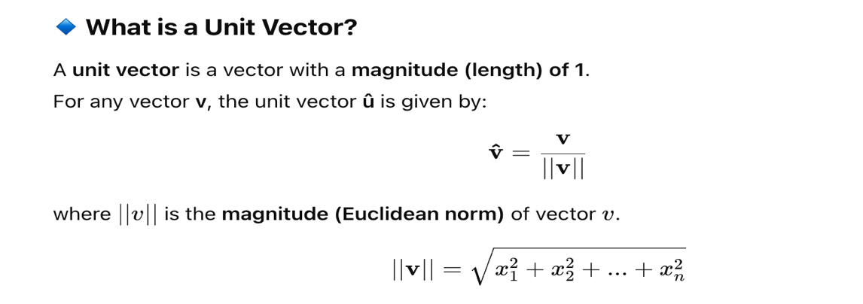

**What is Matrix ?**

A **matrix** is a **rectangular array of numbers** arranged in **rows and columns**. It is widely used in **data science, machine learning, deep learning, and image processing**.

**Basic Matrix Operations:**

* **Matrix Addition and Subtraction**:

* **Scalar Multiplication**:

* **Matrix Multiplication**:

* **Matrix Transposition**:

* **Determinant of a Matrix** :

🔹 **If det(A) ≠ 0 → Matrix is invertible**  
 🔹 **If det(A) = 0 → Matrix is singular (not invertible)**

* **Inverse of a Matrix** :

* **Singular Matrix** : A **singular matrix** is a square matrix that **does not have an inverse**. In other words, its determinant is equal to zero.

* **Non-Singular Matrix**: A **non-singular matrix** is a square matrix that **has an inverse**. This happens when the determinant of the matrix is **non-zero.**

* **Rank of Matrix:** The rank of a matrix is the number of **linearly independent rows** or **linearly independent columns** in the matrix

✅ **Linearly Independent** → No vector in the set can be written as a combination of the others.  
❌ **Linearly Dependent** → At least one vector is a combination of others.

* **Linear Independence** : A set of vectors is **linearly independent** if **none of the vectors can be written as a combination of the others**.
* **Linear Dependence** : A set of vectors is **linearly dependent** if at least **one vector can be written as a combination of the others**.

**Example:**  
Vectors **V1 = [1, 2]**, **V2 = [2, 4]**

**What is a Linear Combination?**

A **linear combination** of vectors means forming a new vector by **scaling** and **adding** given vectors.

**What is Span in Linear Algebra ?**

The **span** of a set of vectors is the **collection of all possible linear combinations** of those vectors.

